## LAB # 6

**LAB TASK :**

Explore all the addressing mode with example with respect to assembly language.

1. **Register Addressing:**

* **Application:** Used for fast data manipulation and arithmetic operations due to high-speed access to CPU registers.
* **Example:**



* **Explanation:** All operands are registers, Commonly used for arithmetic operations

1. **Register Indirect Addressing:**

* **Application:** Used for accessing data stored in memory indirectly through registers.
* **Example:**



* **Explanation:** Used to dynamically access and manipulate data in memory through a register acting as a pointer.

1. **Immediate Addressing:**

* **Application:** Used to load constant values directly into registers
* **Example:**



* **Explanation:** often used for initialization or setting counters.

1. **Displacement Addressing**

* **Application:** Used to access elements in data structures like arrays by adding an offset to a base address stored in a register.
* **Example:**



* **Explanation:** Used for accessing element in an array

1. **Indexed Addressing:**

* **Application:** Used for accessing elements in arrays through index.
* **Example:**

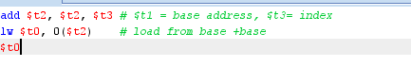

* **Explanation:** helpful for array access when index value is stored in a register.

1. **Direct or Absolute Addressing:**

* **Application:** Used for accessing a specific memory location directly by its address.
* **Example:**

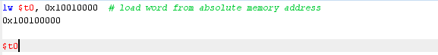

* **Explanation:** Rarely used but essential for hardware specific task like reading from a fixed I/O location.

1. **Memory Indirect Addressing:**

* **Application:** This mode is used to access data stored at a memory location whose address is specified in another memory location.
* **Example:**



**Explanation:** This mode, the instruction specifies a memory location that contains the address of the actual operand, requiring two memory accesses: one to retrieve the address and another to access the operand.

1. **Auto-increment Addressing:**

* **Application:** This mode is used to access sequential data elements, by automatically incrementing the address register after each access.
* **Example:**



* **Explanation:** Often used in loops for iterating over arrays.

1. **Auto-decrement Addressing:**

* **Application:** Access memory sequentially, decrement the pointer automatic.
* **Example:**



* **Explanation:** Useful in reverse traversal of array or stack.

1. **Sealed Addressing: (un common term)**

* **Application:** access fixed, reversed memory for critical function.
* **Example:**



* **Explanation:** Used in secure system or for hardware specific operation

**Conclusion:** In this lab I have explored various addressing modes and their practical applications in assembly language. Each mode specific use. Understanding these mode helps to optimize code for efficiency and performance in low level programming .